**PRACTICAL 1 part 2**

**AIM:.**

**Implement following properties of CSS 2.0.**

**1. Background, Pont and Text**

**2. Margin, Padding and Border (Box Model)**

**3. Table**

**4. Display**

**5. Position**

**6. Floating**

**7. Pscudo elements**

**SOLUTION:**

<!DOCTYPE *html*>

<html *lang*="en">

<head>

    <meta *charset*="UTF-8">

    <meta *http-equiv*="X-UA-Compatible" *content*="IE=edge">

    <meta *name*="viewport" *content*="width=device-width, initial-scale=1.0">

    <title>part 2 Practical1</title>

    <style>

        *{

            margin: 0;

            padding: 0;

        }

        ul{

            background-color: black;

            color: white;

            width: 99vw;

            height: 200px;

        }

        li{

            float: right;

            padding: 10px;

            list-style: none;

        }

li*:hover*{

   color: aquamarine;

}

*.main*{

            font-family: 'Segoe UI', Tahoma, Geneva, Verdana, sans-serif;

            text-align: center;

            color: red;

            border: 4px solid gray;

        }

*.bg*{

            width: 99vw;

            height:90vh ;

            background-repeat: no-repeat;

            background-color: rgba(6, 66, 66, 0.281);

            background-size: 341px 341px;

            background-attachment: fixed;

        }

*.bg1*{

            display: block;

            background-image: url('./Shree\ Krishna\ .jpg');

            background-attachment: fixed;

            background-repeat: no-repeat;

            background-size: contain;

            width: 99vw;

            height:90vh ;

           background-position-x: center;

        }

        table {

        width: 100%;

        font-family: arial, sans-serif;

        border-collapse: collapse;

    }

    th, td {

        padding: 8px;

        text-align: left;

        border-top: 1px solid #dee2e6;

    }

    tbody tr*:nth-child*(odd) {

        background-color: #f2f2f2;

    }

    </style>

</head>

<body>

    <nav>

        <ul>

            <li>About us</li>

            <li>Contact</li>

            <li>Home</li>

        </ul>

    </nav>

    <div *class*="main">

Lorem ipsum dolor, sit amet consectetur adipisicing elit. Similique vero pariatur inventore. Officiis voluptatem nisi fugit, repellat illo nemo odit soluta fuga quos? Sint iste omnis expedita, quam tempore in quibusdam magni consectetur inventore.

<table>

    <thead>

        <tr>

            <th>Row</th>

            <th>First Name</th>

            <th>Last Name</th>

            <th>Email</th>

        </tr>

    </thead>

    <tbody>

        <tr>

            <td>1</td>

            <td>Pritesh</td>

            <td>Vandra</td>

            <td>20dit102@charusat.edu.in</td>

        </tr>

        <tr>

            <td>2</td>

            <td>Harshil</td>

            <td>Thummar</td>

            <td>20dit099@charusat.edu.in</td>

        </tr>

        <tr>

            <td>3</td>

            <td>Raj</td>

            <td>Tejani</td>

            <td>20dit095@charusat.edu.in</td>

        </tr>

    </tbody>

</table>

    </div>

    <div *class*="bg">

<div *class*="bg1">

</div>

    </div>

</body>

</html>

**Output:**

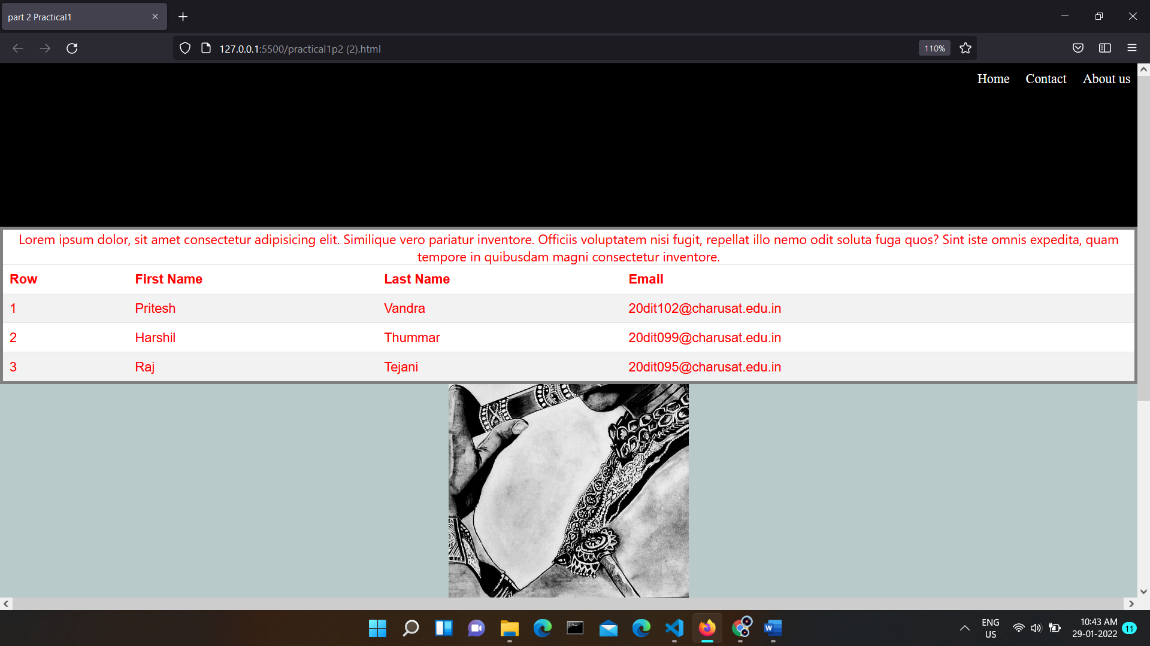

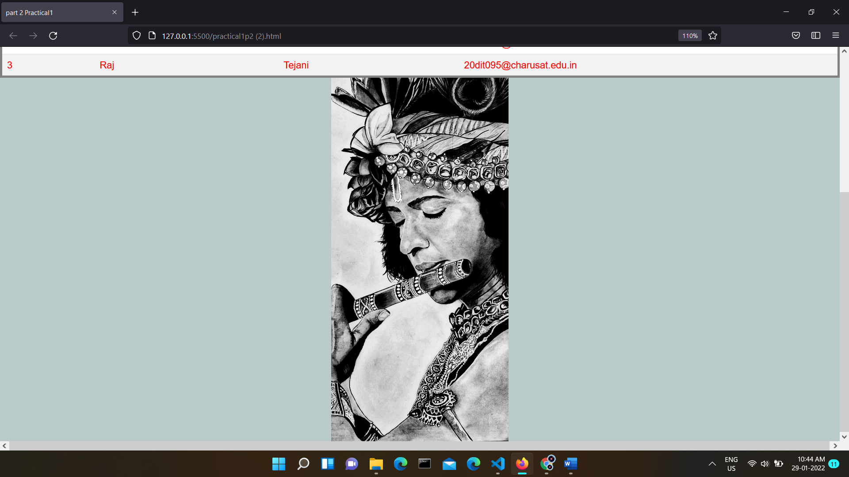

* **Overall output**

**Having image in center and also used background image property**

**Also it is fixed so upper black coloured bar is like some sort of navigation bar.**

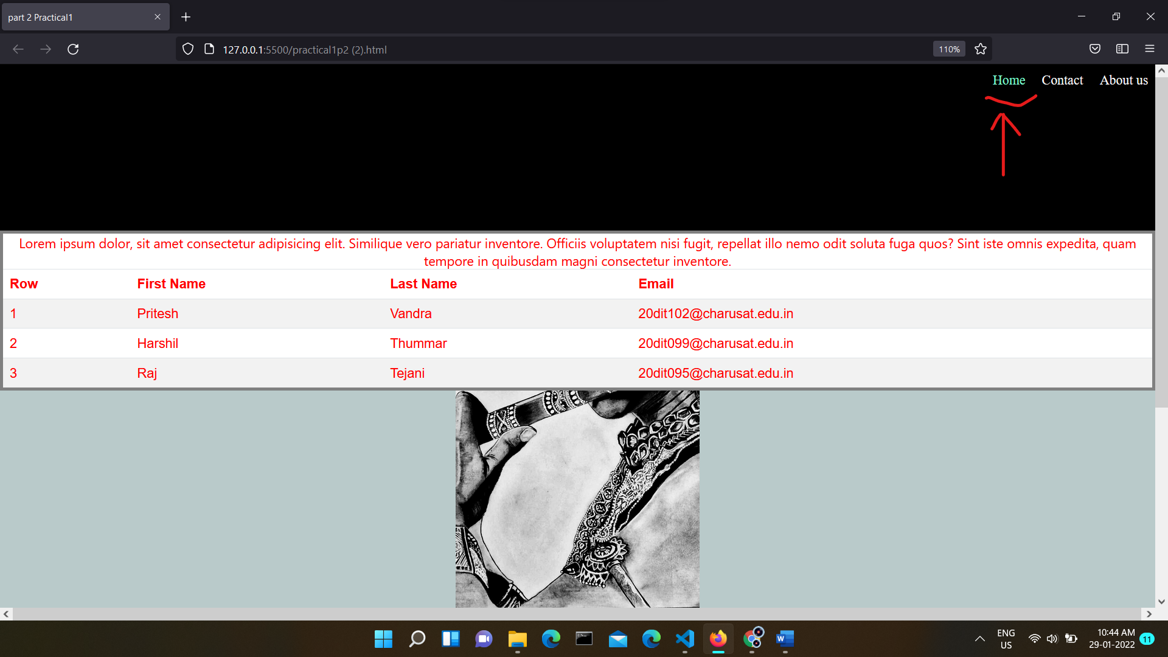

* **Here you may see the hover effect by using psudo elements property of css**

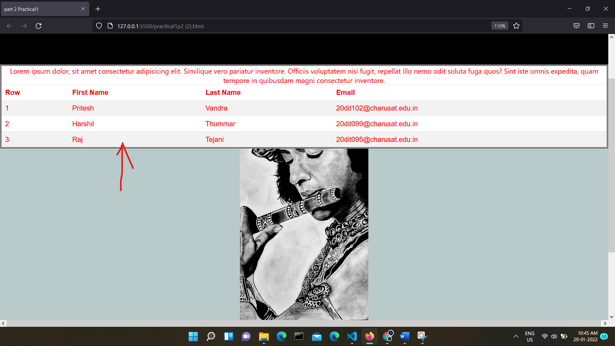

* **as you can see that the colured text is not in the default font type here font property of css comes into picture.**
* **Also text is centered and also some sort of solid border is also given which shows the border and positioning properties of css.**

**Conclusion :**

Here we have used various basic on the go properties of css and made one page (literally can’t say it a web page lol :) ).